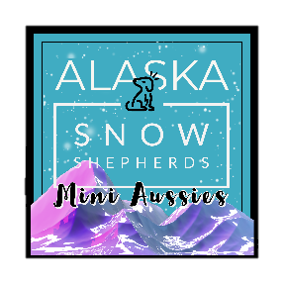

Alaska Snow Shepherds Puppy Agreement and Contract:
Thank you for choosing to home a new family member from Alaska Snow Shepherds!

Purchaser Acknowledgement:
Very Important – Aussies, Corgis and Auggies are HERDING dogs. They need room to grow, are very loyal to their owners, and are extremely intelligent. They will miss you if you are not home, and need to have proper training, exercise, and care. By signing this contract, you acknowledge this fact and promise to provide the best possible care, love, and home for your future baby, and acknowledge you have done research on the breed and their needs/wants. The buyer agrees and binds him or herself to take great care of the puppy, feed, and house him/her properly throughout the duration of his or her life. The buyer further states that he/she will not chain, tie up outside, or otherwise mistreat the puppy/dog. If for any reason you (buyer) can no longer take care of the puppy, you must contact us (Alaska Snow Shepherds / Seller) immediately. We will take the puppy back into our home.
Deposit fee: $500 - If for any reason you are unable to follow through with your purchase before the puppy turns 6 weeks old, your deposit will be refunded less $300.00. If the puppy is 6 weeks old or older your deposit with not be refunded. Breeding rights are an additional $200.00 if desired.
We pride ourselves on having a healthy line of pups! Your puppy is guaranteed to be in good health and up to date on inoculations, tail docking, and dew claws have been removed, and have been to see a veterinarian on a minimum of 2 occasions and health checked. You have 72 hours from purchase / receipt of puppy to have the puppy checked by a licensed veterinarian. In the event a veterinarian finds anything seriously wrong with the puppy we honor an exchange for another puppy, if available, provided a letter from the examining veterinarian is offered as evidence of the puppy’s illness and the puppy must be returned within 72 hours of purchase. If another puppy is unavailable, we will refund your purchase. This has not happened in our litters, but we want to prepare for any unexpected events. Alaska Snow Shepherds assumes no responsibility for the puppy once leaving the premises. Any and all cost incurred, not just veterinary, are the sole responsibility of the buyer.
All Mini Aussie puppies are sold with ASDR registration. A registration form is provided specific to your puppy, and it is your responsibility to register the puppy if you so wish to do so. If you have any questions we are available to help guide you through the process. You will be provided with a bag of kibble for the pup, and a small blanket with mom’s scent for reacclimating the puppy into your home and any other goodies.
I agree to and acknowledge these conditions:
Purchaser: ____________________________________________________ Date: _________________
Address: ___________________________________________________________________________
Phone: _________________________________________________________________
Email: _________________________________________________________________
ASDR Registered Litter # (Mini Aussie) __________________________________

